Project Planning Phase

# Project Planning Template (Product Backlog, Sprint Planning, Stories, Story points)

|  |  |
| --- | --- |
| Date | 22 October 2022 |
| Team ID | PNT2022TMID30264 |
| Project Name | Natural disaster intensity analysis and classification using AI |
| Maximum Marks | 8 Marks |

Product Backlog, Sprint Schedule, and Estimation (4 Marks)

|  |  |  |  |  |  |  |  |  |  |
| --- | --- | --- | --- | --- | --- | --- | --- | --- | --- |
| Sprint | Functional  Requirement | | User  Story  Number | User Story I Task |  | Story Points | Priority | | Team Members |
| Sprint-I | Registration | | USN-I | As a user, I can register for the application by entering my email, password, and confirming my password. |  | 2 | High | | A.lndhumathi |
| Sprint-I | Login | | USN-2 | As a user, I can log into the application by entering email & password |  | 1 | High | | A.lndhumathi |
| Sprint-2 | Data Sync | | USN-6 | Syncing the data given to the website | 3 |  | Medium | | V .Harini |
| Sprint 3 | Enhancement Phase | | USN-18 | Creating a Main web page |  | 4 | High | | Indhumathi A |
| Sprint-4 |  | | USN-19 | Connecting the frontend and backend using API |  | 5 | High | | Kavvya V |
| Sprint-4 | |  | USN-20 | Run the Application | 5 | | high | Sathish H | |  |

Project Tracker, Velocity & Burndown Chart: (4 Marks)

|  |  |  |  |  |  |  |
| --- | --- | --- | --- | --- | --- | --- |
| Sprint | Total Story Points | Duration | Sprint Start Date | Sprint End Date (Planned) | Story Points  Completed (as on  Planned End Date | Sprint Release Date (Actual) |
| Sprint-I | 15 | 3 Days | 24 Oct 2022 | 26 Oct 2022 |  |  |
| Sprint-2 | 42 | 10 Days | 27 Oct 2022 | 10 Nov 2022 |  |  |
| Sprint-3 | 10 | 2 Days | 1 1 Nov 2022 | 09 Nov 2022 |  |  |
| Sprint-4 | 14 | 3 Days | 10 Nov 2022 | 12 Nov 2022 |  |  |

Velocity:

# AV = 18.86/4 = 4 71

Burndown Chart:

|  |  |  |  |  |  |  |  |  |  |  |
| --- | --- | --- | --- | --- | --- | --- | --- | --- | --- | --- |
| |  |  |  |  |  |  |  |  |  | | --- | --- | --- | --- | --- | --- | --- | --- | --- | | O Jira Software | Your work | Projects v | Filters v | Dashboards v | People | Apps v |  | Q Search | |  |



Date - November 4th, 2022 - November 6th, 2022

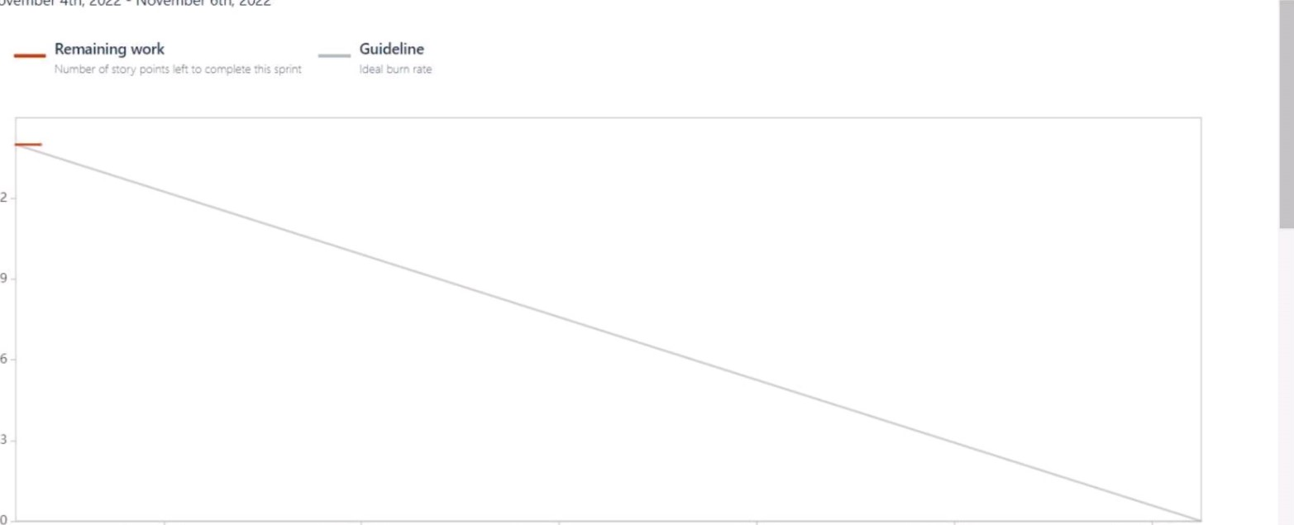

12

Al Based Discourse For... Software project

Back to project

Overview

Bumup report

Sprint burndown chart

Cumulative flow diagram

Cycle time report

Deployment frequency report

01:30 11 Nov 05:30 11 Nov 09:30 11 Nov 01:30 12 Nov 05:30 12 Nov 09.30 12 Nov

Date